Amends
WORD
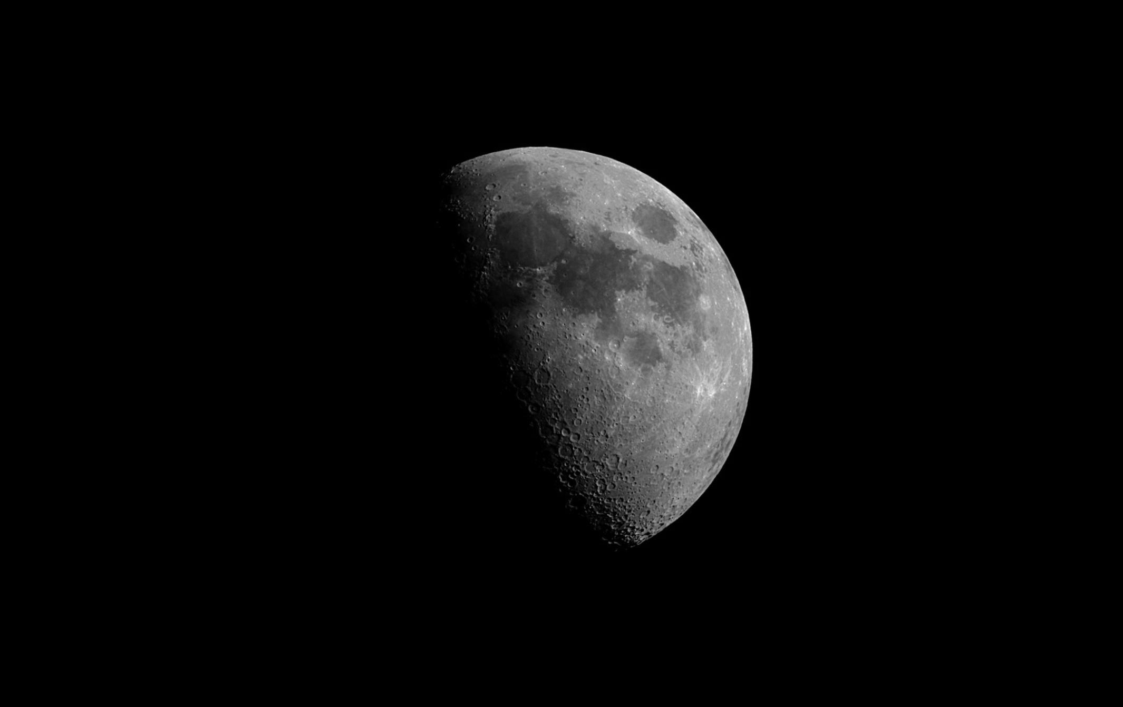
The word choice in “Amends” does very well in suggesting the type of movement that the moonlight is currently engaging in. For example, the words “picks” and “licks” seem to be used in a playful manner, and give the beginning of the poem a lighthearted feeling. The playfulness of the second stanza can suggest that the moon might not quite be taking itself seriously yet. As the poem moves on, though, the words suggest that the pace of the moonlight increases; for example, phrases like “unavailing pours” and “soaks” seem more purposeful. Eventually it seems to “arrive” at its destination, which is marked by the word “dwells,” and would be the sleepers.
Form
The form of the poem is very erratic, with no foreseeable pattern, which may suggest how unpredictable the moonlight is. The lines go from long to short and back, which can show that the moonlight is everywhere, in areas normally unreachable. The form of the poem does give us a few ideas of how the moonlight acts as well, as, in the beginning, the moonlight is a bit unpredictable and it is hard to decipher what it is trying to do.
Imagery/Ideas
The whole of the poem is a big piece of imagery, as it personifies the moonlight all the way through as being able to move in a human-like way. This goes well with the word choice picked in the poem, which also accentuates the human qualities of the moonlight as it moves towards its destination. The poem also contradicts that though, by using words that suggest that the moonlight isn’t human. This may again suggest the omnipotent and omnipresence of the moonlight, which everything else seems to be trying to emphasize as well. The imagery used in Amends is quite obvious and strong.
The ideas in Amends are not very obvious in the poem, and seem to be very debatable. The poem could be trying to suggest that the moonlight makes amends for all that happens during the day. It could also be trying to say that the moon wants to be with the humans, but since they are always asleep during the night, it’s impossible for it, therefore it makes amends that it cannot be with them. These questionable meanings could also add to the enigma of the moonlight and the poems mysteriousness.
Rhyme/Rhythm
Amends doesn’t quite have a rhyme to it, but it certainly has a rhythm. The way it starts almost every line with “as it” makes the poem one big list, and makes it seem like it just goes on and on and on continuously. This could hint at the overwhelming power of the moonlight, and how it’s unstoppable.
Structure
The structure of this poem seems to be like starting a video. First, the view is at a complete stop, or the night with the tree. Then, it suddenly starts off with an explosion of stars out of the bark of the tree, while everything around seems to also begin moving at the same time. As it continues, it increases in speed until it’s practically fast-forwarding, and it suddenly slows down to a halt at the sleepers where it could even be said to almost pause again. The effect of this is that it seems to show you a scene without any context at all. This yet again adds to the mysteriousness of this poem, and the parts of it that we don’t understand.
Tone
The tone of this poem is a mysterious one, describing an unknown, but seemingly omnipotent power moving across the landscape. This tone emphasizes the moonlight’s enigmatic nature in the poem, and creates an awestruck effect on us. It also seems be slightly sad, or lonely, as the poem appears to resonate the idea of how nothing else in the world is alive, and it is only the moonlight by itself on the journey that it has undertaken to reach the sleepers. Of course, this makes us sympathize with the moon, and how it doesn’t have a partner or somebody to talk to.

